GEOG 576 ADVANCED WATERSHED ANALYSIS
Exercise 1. Watershed delineation and National Hydrography Dataset
*Note*. ** SAVE YOUR MXD FILE IN YOUR CLASS DIRECTORY ON THE Z: DRIVE (e.g. z:\geog576\g576-01), NOT ON THE C: DRIVE. ** If you save to the C drive, your data will be lost if you login to a different computer, and may disappear overnight.
** Be sure to save all data and projects in this mapped Z: folder, not the C: drive! **
You will be assigned one of the following (or choose your own USGS gage):
USGS Gage list:
Los Coches 11022200;
Sweetwater River near Descanso 11015000
San Diego River at Mast Drive 11022480
San Diego River at Fashion Valley, 11023000
San Vicente Reservoir nr Lakeside, 11022100
El Capitan Reservoir nr Lakeside, 11020600

- Open ArcGIS, and open your EX0.mxd file.

- Load National Hydrography Dataset in ArcGIS
Data on watershed boundaries, DEMs, streamlines, stream gages, etc, can be obtained from the National Hydrography Dataset (NHD). NHD data source:
http://www.horizon-systems.com/nhdplus/)
NHD data for this class will be on the Y: drive.
The User Manual for the NHD V2 is at http://www.horizon-systems.com/NHDPlus/NHDPlusV2_documentation.php#NHDPlusV2%20User%20Guide
- Using the “Add data” icon, add the NHD flowlines.
“Folder Connections\Y:\spatial_data\NHDPlusV2\NHDH1807.mdb\Hydrography\NHDFlowline”
  - Change the legend. In the Table of Contents, double click on the line in the legend to change the color and width of the flowlines (e.g. stream should be thick blue, etc).

- Add the NHDStreamGageEvent shapefile from Y:\Data\spatial_data\NHDPlusV2\
Explore the Gage data. Approximately how many gages (e.g. 10, 100) are there in San Diego County?
Use the Info button to explore the data for a few gages, and to look up the data on the website using the url in the attribute table.
3.1 Label the gages with the USGS code.
In the TOC, right click the NHDStreamGageEvents_SDIV layer, and “Label Features.” Then, right click it again, and go to “Properties” > “Labels”, and choose the Label Field as SOURCE_FEA:

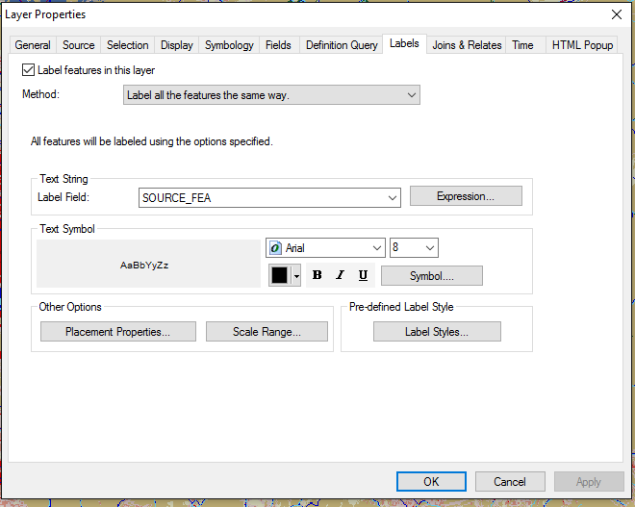

That will label each point with the USGS gage code.
- Flow accumulation grids
NHD has sink-filled DEMs and flow accumulation grids. For this class, it has been clipped to the SD-IV area: Y:\Data\spatial_data\NHDPlusV2\facc_SDIV.tif
- Load Flow accumulation layer into your project.

- Display stream network using the flow accumulation grid.
Display the facc_SDIV grid, with streams in blue and non-stream cells white.
Right click the layer in the TOC, select “Properties”, and experiment with a single break value (see steps 1-5 in the screenshots below).

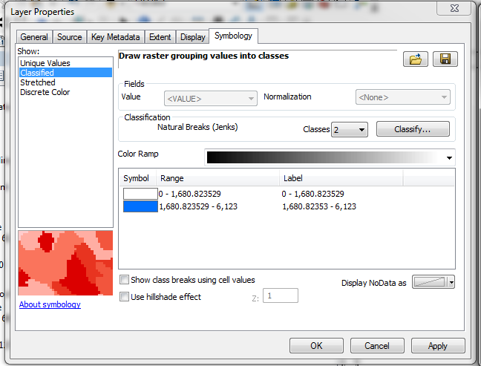
1
2
3
Change break value

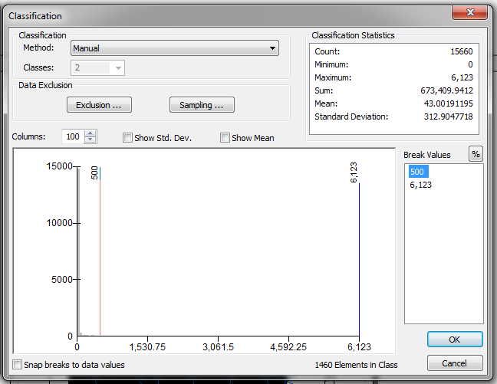
4
Experiment with different break values (the bottom number is the maximum in the grid and doesn’t change)

5 change colors
Make background “No color”
Which break value fits the NHD flowlines the best?
What drainage area does this correspond to? Hint: cell size is 30 m.

- Choose your USGS gage and check USGS drainage area against flow accumulation grid
- Select and save your assigned USGS gage as a separate shapefile.
- Right click on the NHDStreamEvents layer, then “Make this the only selectable layer”.
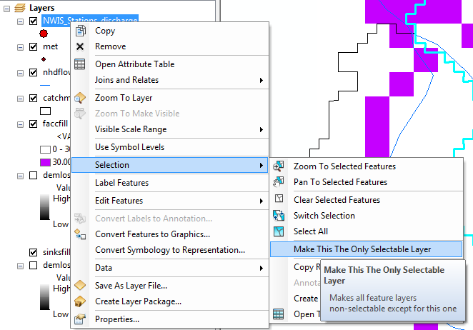

- Select your gage by:
Right click the layer name in TOC, select “Open Attribute Table”. Then select the row containing your gage—it should be highlighted in Blue. Hint, you can right click the SOURCE_FEA column and sort it to make finding your gage easier.
- Check out the metadata by clicking on your streamgage with the information tool and clicking the url weblink in the FEATUREDET field.
  - With your streamgage still selected, right click on the layer and “Data > Export Data”, save it *in your Z: drive* as some filename that makes sense to you, but include the USGS code in the filename.
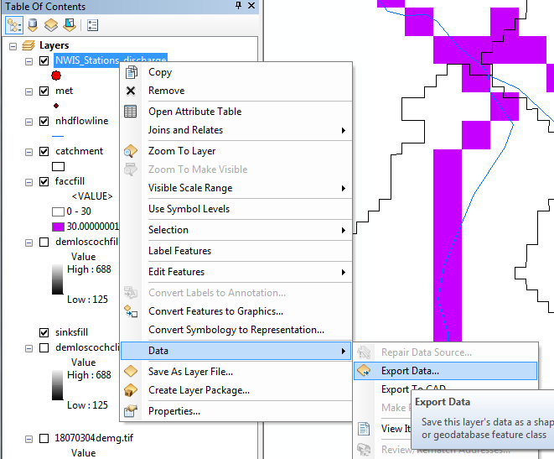

- Check locational accuracy of the gage by checking flow accumulation against drainage area.
- Look up the drainage area for the USGS gage using the metadata at the URL.
- Convert the drainage area to # of cells (Hint: cell size is 30m)
- Find the cell on the flow accumulation grid with a similar # of cells as the USGS drainage area.
- Is it near the stream gage? How far away is it?

For Los Coches gage, USGS drainage area: 12.2 mi²
12.2mi² x 1609^2 m²/mi² x 1cell/30mx30m = 35093 cells

- POUR POINT IDENTIFICATION
- Open the ArcToolbox .
- Find Spatial Analyst Tools > Hydrology > Snap Pour Point.***

*** If you get an error message “Tool Not Licensed. Unable to execute the selected tool.”, you need to add the Spatial Analyst extension:
In the GUI menu in ArgGIS, select Customize > Extensions, and check on “Spatial Analyst”.

- Choose your USGS gage station layer, and the flow accumulation layer where specified by the GUI.

Note: The pour_point_field needs to be a field in your stream gage shp that has unique numeric values. To look at the fields and their values in your USGS gage feature dataset, right click the layer and “Open Attribute Table”. There are a few fields that may work; I used “FID”.

How should you determine the value of the snap distance?

- WATERSHED DELINEATION
- Use the Watershed command ( “Spatial Analyst Tools > Hydrology > Watershed”) and your snapped pour point raster (*not* your shapefile of the point) to delineate the watershed at your USGS gage. ** Be sure to use the flow direction grid (fdir_SDIV), not the flow accumulation grid.
- Convert the watershed grid to a polygon using “Conversion Tools > From Raster > Raster to Polygon.”

- water quality issues in your watershed
- Add the 303(d) list shapefile to your map:
Y:\spatial_data\EPA303d\ 2010_303d_EPAapr_lines121211.shp.
- Identify and write down the names of up to 3 reaches in your watershed that are on the 303(d) list using the info tool. If there are no 303(d) reaches in your watershed, find the nearest reach that is on the 303(d) list.
- Go to CA’s website for 303(d):
http://www.waterboards.ca.gov/water_issues/programs/tmdl/integrated2010.shtml
to find out what the water quality problems are in the reaches you wrote down in step B.

- PROJECT WATERSHED BOUNDARY INTO SAME PROJECTION AS NLCD:
It is easiest to project all the data into the same projection in ArcGIS, then you don’t have to worry about projections in R, which are complicated.

Project the watershed boundary into the projection of the NLCD using:
- > Data Management Tools > Projections and Transformations > Project.
(see screenshot next page)
Under “Output Coordinate System”, choose “Import” and the NLCD cover.

